|  |  |
| --- | --- |
| Name | Muhammad Arslan Raza |
| Roll no. | 2020-EE-403 |
| Section | A |

**Lab No.8**

**DEMONSTRATION OF THE WORKING OF VAPOR**

**ABSORPTION CYCLE**

**Introduction:**

The vapor absorption refrigeration system comprises of all the processes in the vapor compression refrigeration system like compression, condensation, expansion and evaporation. In the vapor absorption system the refrigerant used is ammonia, water or lithium bromide. The refrigerant gets condensed in the condenser and it gets evaporated in the evaporator. The refrigerant produces cooling effect in the evaporator and releases the heat to the atmosphere via the condenser.

The major difference between the two systems is the method of the suction and compression of the refrigerant in the refrigeration cycle. In the vapor compression system, the compressor sucks the refrigerant from evaporator and compresses it to the high pressure. The compressor also enables the flow of the refrigerant through the whole refrigeration cycle. In the vapor absorption cycle, the process of suction and compression are carried out by two different devices called as the absorber and the generator. Thus the absorber and the generator replace the compressor in the vapor absorption cycle. The absorbent enables the flow of the refrigerant from the absorber to the generator by absorbing it.

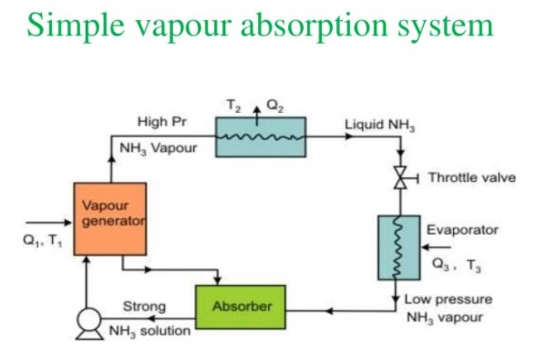Another major difference between the vapor compression and vapor absorption cycle is the method in which the energy input is given to the system. In the vapor compression system the energy input is given in the form of the mechanical work from the electric motor run by the electricity. In the vapor absorption system the energy input is given in the form of the heat. This heat can be from the excess steam from the process or the hot water. The heat can also be created by other sources like natural gas, kerosene, heater etc. though these sources are used only in the small systems.

**Part Lists:**

1. 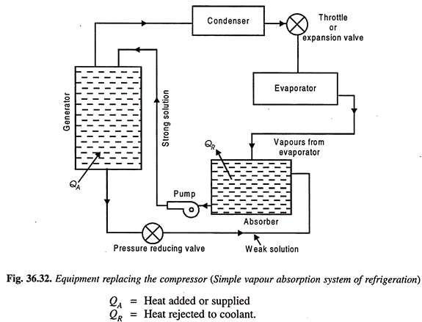**Condenser**
2. **Expansion valve or restriction**
3. **Evaporator**
4. **Absorber**
5. **Pump**

**EXPLANATION OF PARTS:**

**1) Condenser:**

Just like in the traditional condenser of the vapor compression cycle, the refrigerant enters the condenser at high pressure and temperature and gets condensed. The condenser is of water-cooled type.

**2) Expansion valve or restriction:**

When the refrigerant passes through the expansion valve, its pressure and temperature reduce suddenly. This refrigerant (ammonia in this case) then enters the evaporator.

**3) Evaporator:**

 The refrigerant at very low pressure and temperature enters the evaporator and produces the cooling effect. In the vapor compression cycle this refrigerant is sucked by the compressor, but in the vapor absorption cycle, this refrigerant flows to the absorber that acts as the suction part of the refrigeration cycle.

**4)Absorber:**

 The absorber is a sort of vessel consisting of water that acts as the absorbent, and the previous absorbed refrigerant. Thus, the absorber consists of the weak solution of the refrigerant (ammonia in this case) and absorbent (water in this case). When ammonia from the evaporator enters the absorber, it is absorbed by the absorbent due to which the pressure inside the absorber reduces further leading to more flow of the refrigerant from the evaporator to the absorber. At high temperature water absorbs lesser ammonia, hence it is cooled by the external coolant to increase it ammonia absorption capacity.

**5) Pump:** When the absorbent absorbs the refrigerant strong solution of refrigerant-absorbent (ammonia-water) is formed. This solution is pumped by the pump at high pressure to the generator. Thus, pump increases the pressure of the solution to about 10bar.

**6) Generator:** The refrigerant-ammonia solution in the generator is heated by the external source of heat. This is can be steam, hot water or any other suitable source. Due to heating the temperature of the solution increases. The refrigerant in the solution gets vaporized and it leaves the solution at high pressure. The high pressure and the high temperature refrigerant then enter the condenser, where it is cooled by the coolant, and it then enters the expansion valve and then finally into the evaporator where it produces the cooling effect. This refrigerant is then again absorbed by the weak solution in the absorber.

**Explanation:**

Vapor Absorption Cycle Consists of Following Process

**1: Compression**

**2: Condensation**

**3: Expansion**

**4: Evaporation**

The initial flow of the refrigerant from the evaporator to the absorber occurs because the vapor pressure of the refrigerant-absorbent in the absorber is lower than the vapor pressure of the refrigerant in the evaporator. The vapor pressure of the refrigerant-absorbent inside the absorbent determines the pressure on low-pressure side of the system and also the vaporizing temperature of the refrigerant inside the evaporator. The vapor pressure of the refrigerant-absorbent solution depends on the nature of the absorbent, its temperature and concentration.

When the refrigerant entering in the absorber is absorbed by the absorbent its volume decreases, thus the compression of the refrigerant occurs. Thus, absorber acts as the suction part of the compressor. The heat of absorption is also released in the absorber, which is removed by the external coolant.

When the vaporized refrigerant leaves the generator, weak solution is left in it. This solution enters the pressure reducing valve and then back to the absorber, where it is ready to absorb fresh refrigerant. In this way, the refrigerant keeps on repeating the cycle.

The pressure of the refrigerant is increased in the generator; hence it is considered to be equivalent to the compression part of the compressor.

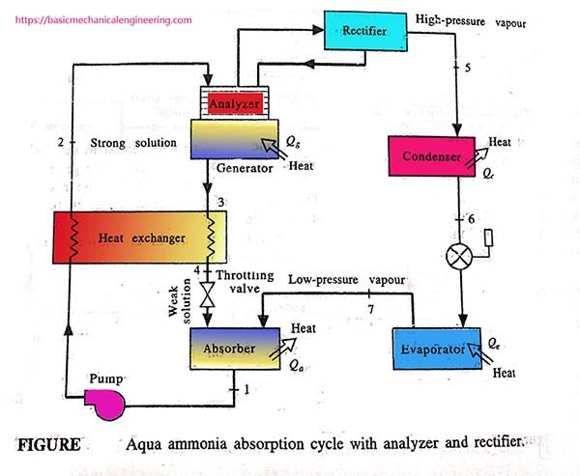

**Applications of VARS differs from VCRS in many ways:**

1. VCRS is usually applied in small applications like home refrigerators and Small capacity AC's but VARS has to be applied for bigger tonnage plants.
2. VCRS doesn’t need that much of installation and maintenance as that of VARS.;
3. VCRS applications are simple and compact but applications of VARS are complex and space consuming
4. Energy efficiency ratings of VCRS is less than that of the VARS

Most of the halocarbon refrigerants used in the compression refrigeration system produces greenhouse effect. As per the Montreal Protocol, their use has to stop completely by the year 2020. In the absorption refrigeration system, no refrigerant produces the greenhouse effect, so their use won’t be stopped in future.

Note: VCRS= vapor compression refrigeration system

VARS= vapor absorption refrigeration system